COSC 471/571 Homework HW1011 assigned: 10/11/2018 due: 10/18/2018

Consider the following database abbreviated ER diagram and schema.

Suppose each sector contains 1024 usable bytes. Records are unspanned.

1. T1 contains 10,000 records
T2 contains 10,000 records
LU contains 24,000 records
T3 contains 5,000 records

1 a. How many bytes are required for each data file?

1. b. How many sectors are required for each data file?

2. The three most common SQL queries are:
SELECT T1.SSN, T1.a, T2.city, LU.c
FROM T1, T2, LU
WHERE T1.PK = LU.T1_PK and
T2.PK = LU.T2_PK

SELECT T2.city, T2.state, T3.PK
FROM T2, T3
WHERE T2.PK = T3.FK
ORDER BY T2.state

SELECT *
FROM T1
WHERE T1.lname LIKE ‘%son’ OR
T1.lname LIKE ‘%sen’

There is a hard limit on the available space for indexes. That limit is 20% of your total space for the data files.

To get the best performance from your database, which indexes should you build?

Give your answer in the following format (expand or shrink the table as desired):
Type of index (primary, secondary, clustering) | Datafile | Attribute(s) | Dense or sparse | Index record  size | Total space required for index

3. Identify the most important index in #2 and justify that choice. Justify both the existence of the index and why it is the most important.

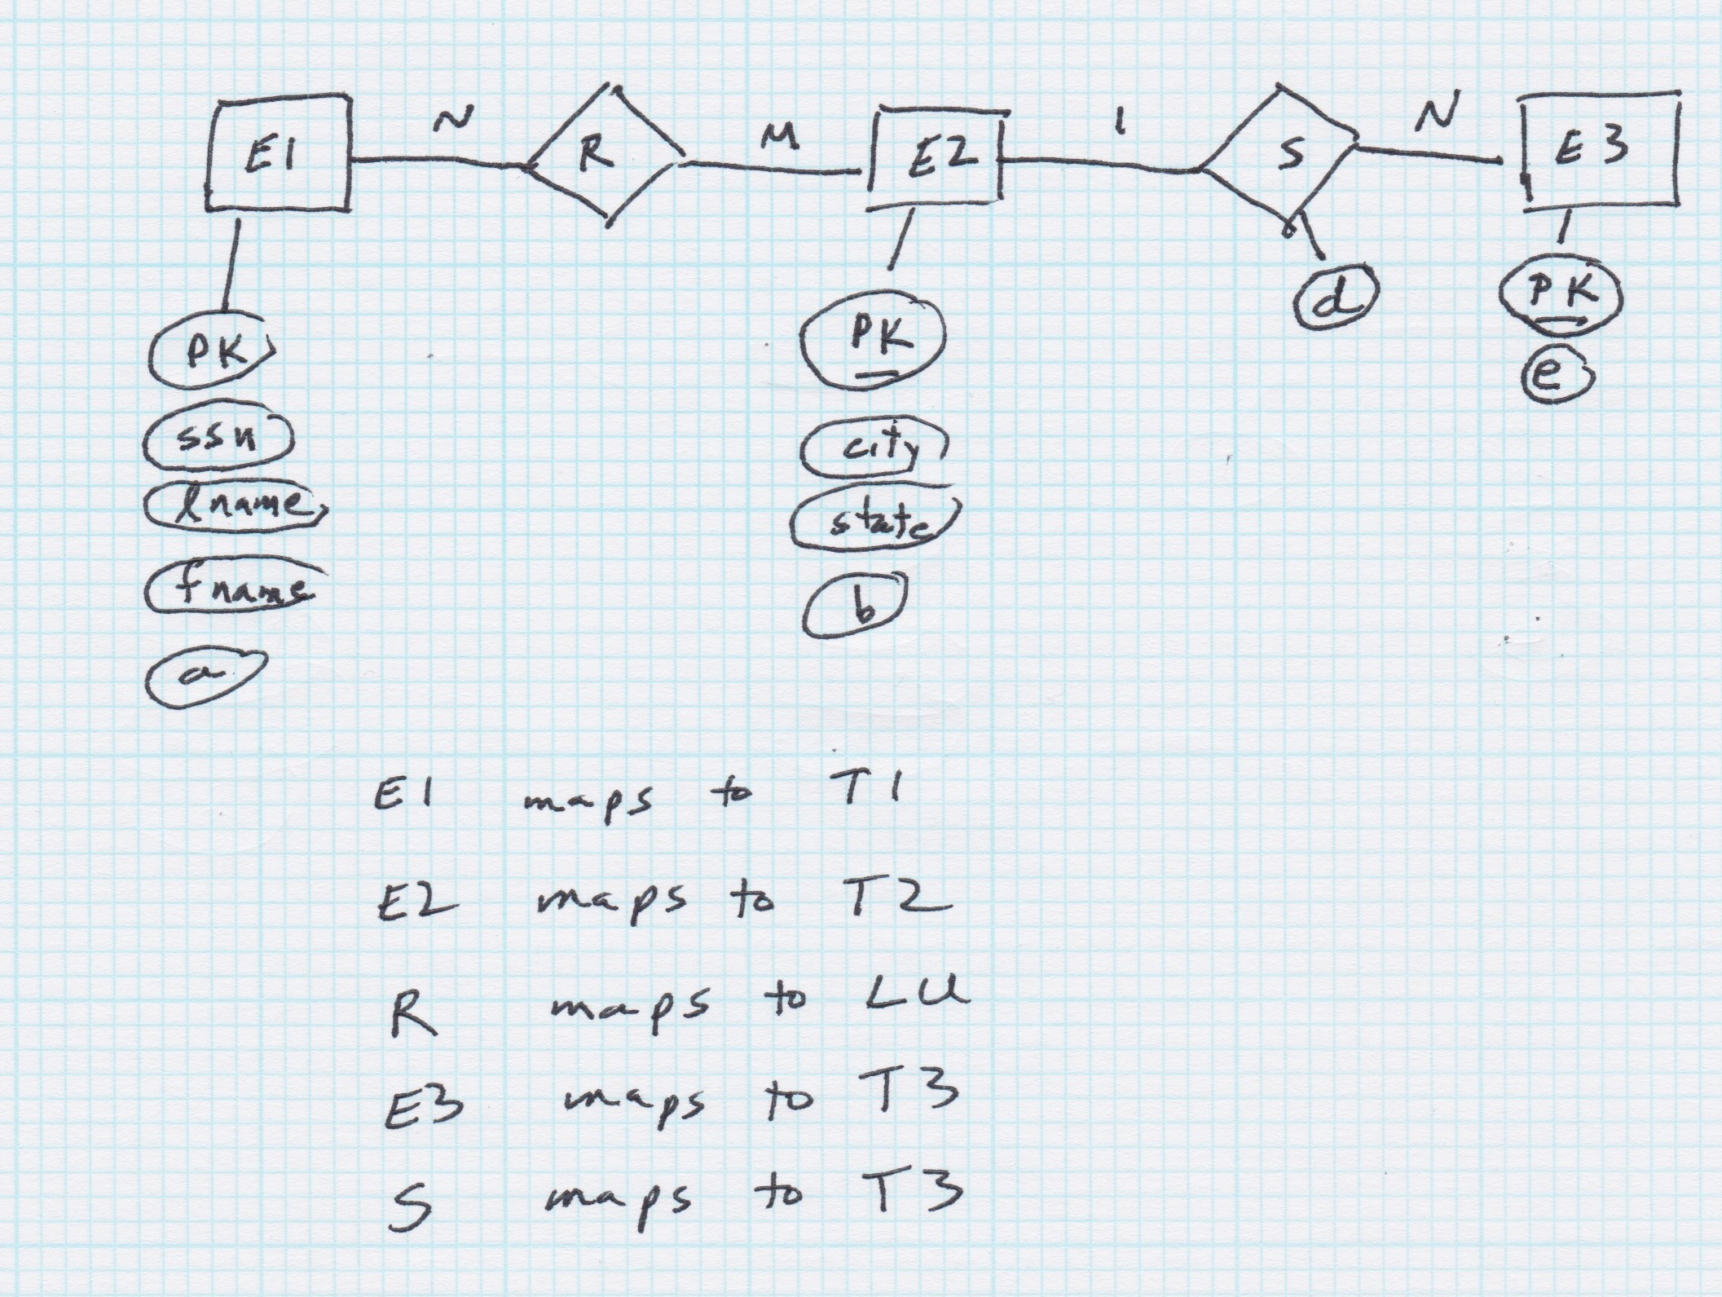

INT requires 4 bytes
CHAR requires 1 byte
DATE requires 8 bytes

T1
PK : INT as primary key
ssn : CHAR(9)
lname : CHAR(50)
sname : CHAR(50)
a : INT

T2
PK : INT as primary key
city : CHAR(50)
state : CHAR(2)
b : INT

LU
T1_PK : INT as foreign key referencing T1.PK
T2_PK : INT as foreign key referencing T2.PK
c : CHAR(100)

T3
PK : DATE as primary key
FK : INT as foreign key referencing T2.PK
d : CHAR(50)
e : IN

