1935 Social Security, Version 1: Highly Simplified
- The yearly median US household income in 1935 was $1,285. Suppose we target that when you retire, you get about 45% of your pre-retirement income from Social Security. What does this work out to, yearly: $___.__
- Let's say there would be about 3.3 million households on Social Security. And, we will assume that the people who are currently retired were making the median income before they retired (all properly adjusted for inflation, so we can ignore inflation in our calculations.) What is the total amount of money paid out yearly: $___,___,___,___
- The following calculations are just to put this spending in context, and are not used subsequently:
- The amount the US Federal Government spent in 1935 was about $6.4 billion, not including SocSec (because it didn't exist yet). If they had added the amount in Question 2 to spending, that would have been a __% increase.
- The amount the US Federal Government got in taxes in 1935 was about about $3.6 billion, again not including SocSec. If they had added the amount in Question 2 to taxes, that would have been a __% increase.
- The US GDP in 1935 was about $69.6 billion. The amount in Question 2 would have been __% of GDP. (GDP=Gross Domestic Product, a measure of how big the whole economy is)
- Let's say there were 34.2 million non-retired households in 1935. If SocSec was purely a pay-as-you-go system, with the taxes that current workers pay going directly to current retirees (as opposed to saving any/some/all money for future use), how much would each working household have to pay in SocSec taxes to fund the total amount of money you calculated above? yearly: $___________
- What is this as a percent of the median household income? _____% This is roughly the SocSec tax percentage of a person's yearly income, though many plans have it paid half by the employee and half by the employer.
- We could have found that percentage as follows: The worker/retiree ratio is about 34.2/3.3=10.3/1, so 10.3 workers have to pay a total of 45% of a yearly income to support 1 retiree, and 45/10.3 = ___%
- Which of the above numbers could we change by writing the law differently? Circle them.

1935 Social Security, Version 2: still a bit Simplified
The benefit level is not actually a plain percentage of the income. Instead, there are various different percentages that apply, depending on which income bracket you are in (the same concept, but not the same numbers, as income-tax brackets). Here is the rule for determining the monthly benefit ("Primary Insurance Amount", or PIA):
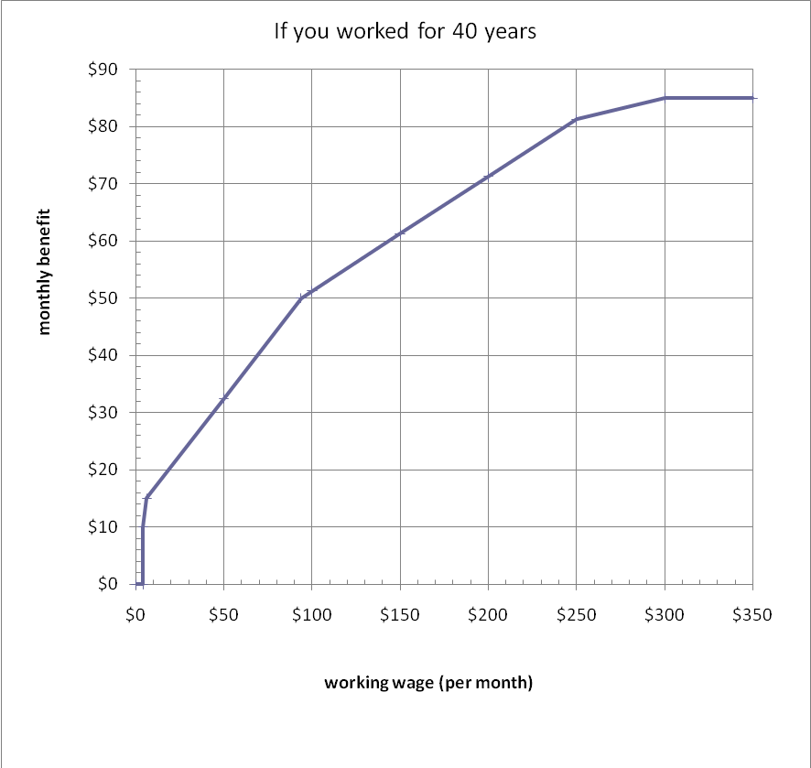
Based on that graph, please fill out the blank spots in this table, for a highly simplified sample of 10 households (income amounts chosen to roughly match the whole population). You should make sure you understand where the first PIA amount comes from, so you're on the right track:
Yearly Income | Monthly Income | # such households | PIA: Monthly benefit per household | yearly benefit per household | Yearly total for these households | PIA as a % of monthly income
$700 | $58 | 6 | $35.83
$1730 | $144 | 3
$5285 | $440 | 1
 |  |  |  |  | Total : $5763
If the total yearly payout is roughly $5763 for these 10 households, what would the yearly total payout be for 3.3 million retired households?

Here is a graph of PIA/monthly income before retiring. The numbers in your last column above should match this graph:
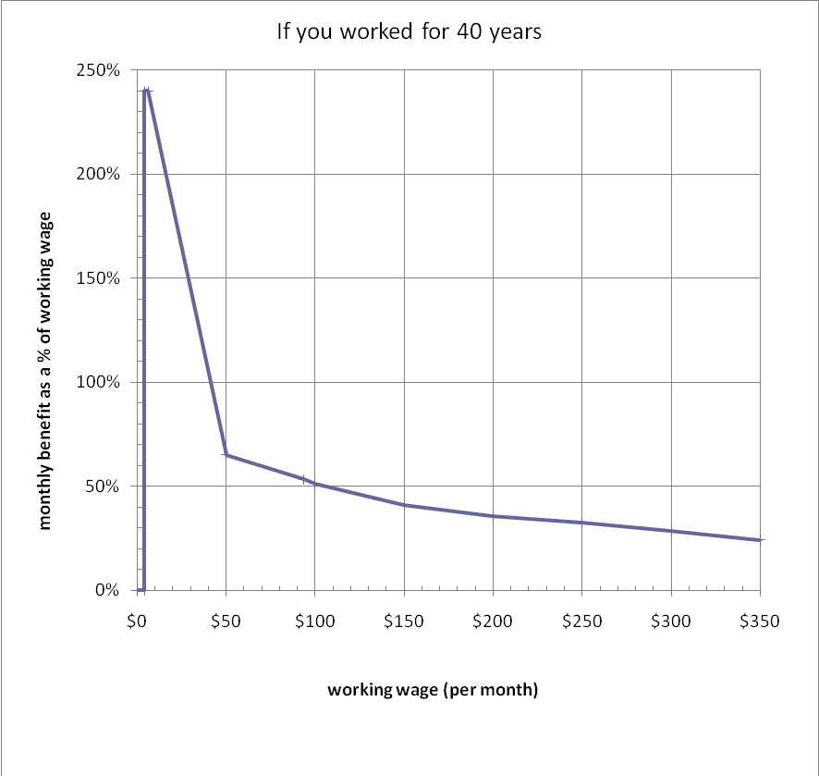
Now compute the total paid in by each household (at a SocSec tax rate of 4.34% on the first $3000/year, and 0% on the amount over $3000, for 40 years) and the total paid out in benefits (for 10 years). The # households of each type is not important.
Yearly Income | Total tax paid in 40 years |  | PIA: copy from above |  | yearly benefit per household |  | Total benefits paid over 10 years |  | Total benefits/ Total tax paid
$700 |  |  | $35.83
$1730
$5285
Notice that each type of household is getting back well more than they put in, if they survive for 10 years in retirement. How does this work in the long run?

