Let’s play chess!

In class exercise for 2-dimensional arrays.

We wish to develop a program that will graphically display how rooks and bishops move in the game of chess.

Rooks can move horizontally or vertically from where they are placed. That is , they move along a row or column

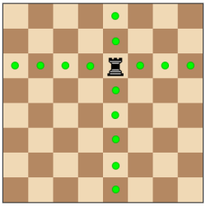

Bishops may move along diagonals, as demonstrated here:

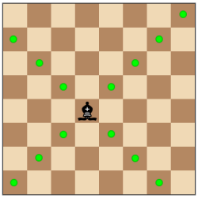

We will assume a board is a two-dimensional array of char. The upper left hand corner is board[0][0] and the lower right-hand corner is board[7][7]. We assume coordinates of the board are given by board[row][column].

In our illustration, the rook occupies board[2][4] and the bishop occupied board[4][3].

You should design a object class called ChessBoard that contains an instance variable called board. board is a 2 dimensional array.

The class should have the following methods:

-a zero parameter constructor that sets each element of board to ‘E’ (empty)

-a toString method that will output the contents of the board. For example

ChessBoard myBoard=new ChessBoard();
System.out.println(myBoard);

Would output

EEEEEEEE
EEEEEEEE
EEEEEEEE
EEEEEEEE
EEEEEEEE
EEEEEEEE
EEEEEEEE
EEEEEEEE

After building the string to output, the toString method should re-initialize the board to all E.

-a void method rook(int row, int col) . This method will update the board to indicate all squares a rook may move to from the position board[row][col]
For example

ChessBoard myBoard=new ChessBoard();
myBoard.rook(3,2);
System.out.println(myBoard);

would output:
EEREEEEE
EEREEEEE
EEREEEEE
RRRRRRRR
EEREEEEE
EEREEEEE
EEREEEEE
EEREEEEE

- a void method bishop(int row, int col). This method will update the board to indicate all squares a bishop may move to from the position board[row][col]

For example:

ChessBoard myBoard=new ChessBoard();
myBoard.rook(3,2);
System.out.println(myBoard);
myBoard.bishop(6,3);
System.out.println(myBoard);

would output:

EEREEEEE
EEREEEEE
EEREEEEE
RRRRRRRR Output after rook move
EEREEEEE
EEREEEEE
EEREEEEE
EEREEEEE

EEEEEEEE
EEEEEEEE
EEEEEEEB
BEEEEEBE Output after bishop move. Note board
EBEEEBEE was re-initialized to empty first
EEBEBEEE
EEEBEEEE
EEBEBEEE

