COSC 511 Final, at home test 13Dec 2014 Name:
Open book, notes, internet. Do not interact with another human. If you use a program to help solve the problem, give the code and prepare to do a walk-thru.

Return via email by 5pm, Sunday 14 December

- Solve the sequence alignment problem (see Kleinberg & Tardos, 6.6)

Align two lower-case strings according to the cost function described here.

Gap cost = δ 3
Exact match 0
Character mismatch 1

As an example, the following alignment
camping
|||||||
s---ing
has a cost of 10 (1 + 3 + 3 + 3 + 0 + 0 + 0)

The two strings you will align are “align” and the first four characters of your name (“c0c1c2c3”) – convert your name string to all lower-case.

A. Complete the optimal alignment M by filling in the matrix (in the style of Figure 6.18). Only give the matrix – do not show calculations

a |
|
l |
|
i |
|
g |
|
n |
|
- |
|
| - c0 c1 c2 c3

B. Give the minimum cost.

C. Give all alignments that have the minimum cost.

2. Consider this network.

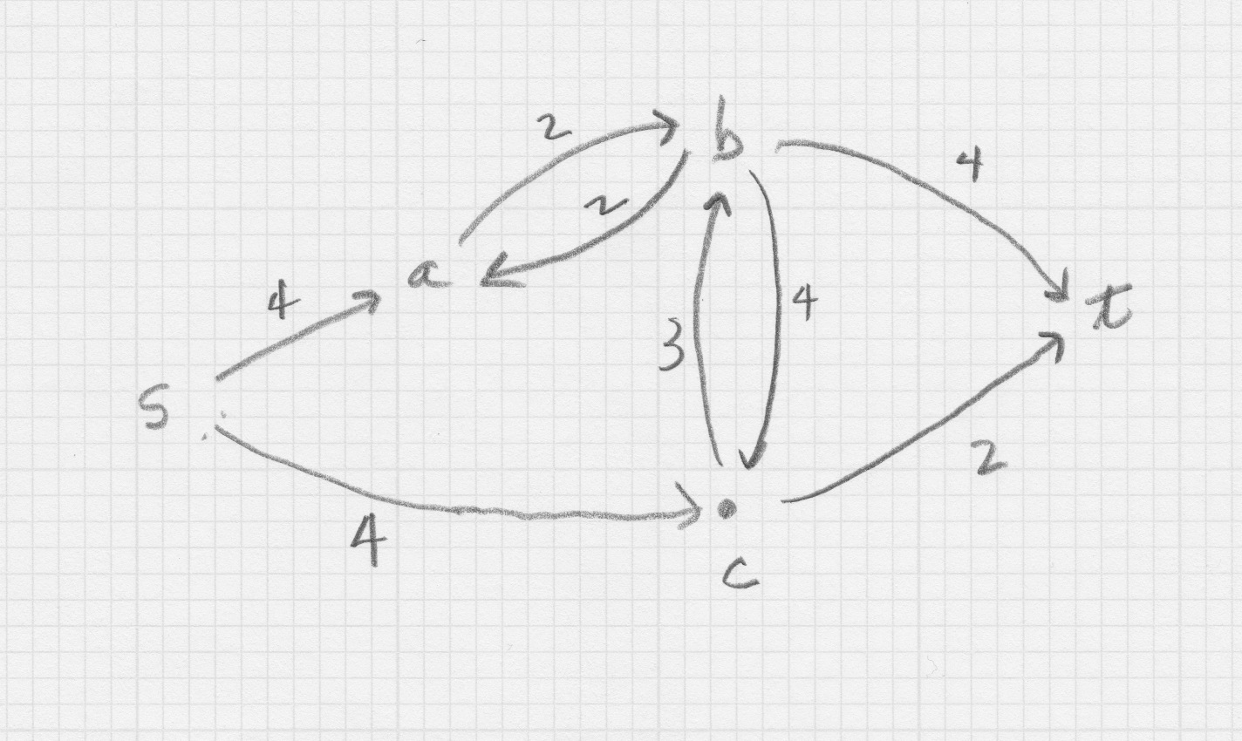

A. Give the maximum flow (do not give intermediate results)

B. Give one minimum cut (do not give intermediate results).

3. Using the contraction algorithm to find global minimum cut of this network.

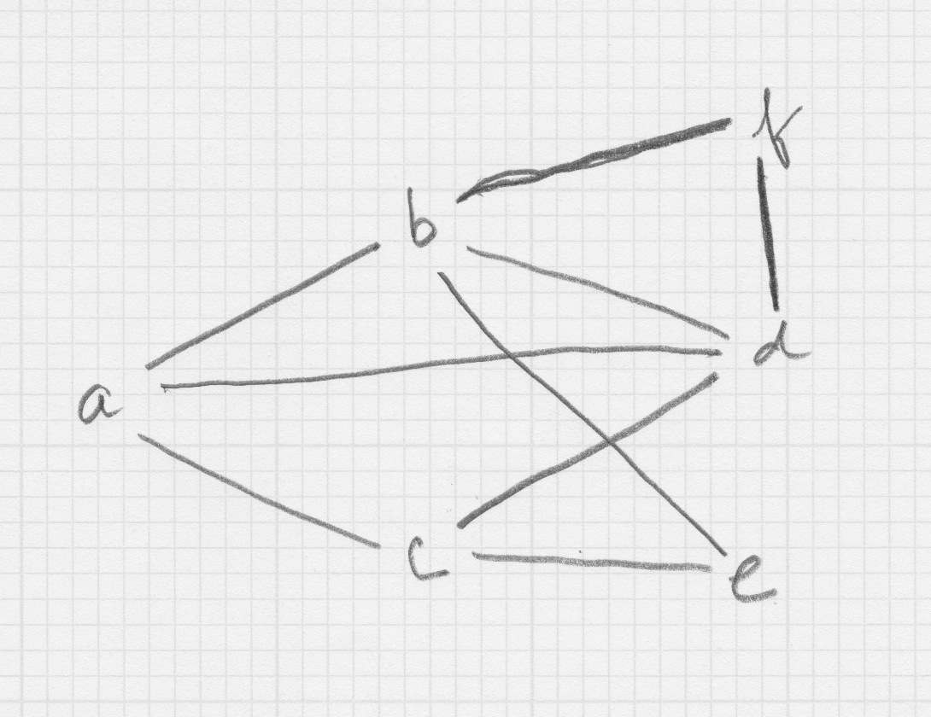

A. Show the intermediate result after contracting the following edges in the order given: (ab), (cd).

B. Give a result from completing the algorithm from the start in part 3.A. Do not give any other intermediate results.

C. Give a global minimum cut that is different from the cut you obtained in part 3.B. Do not show your work.

